Flask Git Assignment Submission
Name: Omkar Wagh
Repository: flask-assignment

1. Repository Setup
Created GitHub repository and pushed initial Flask project files.
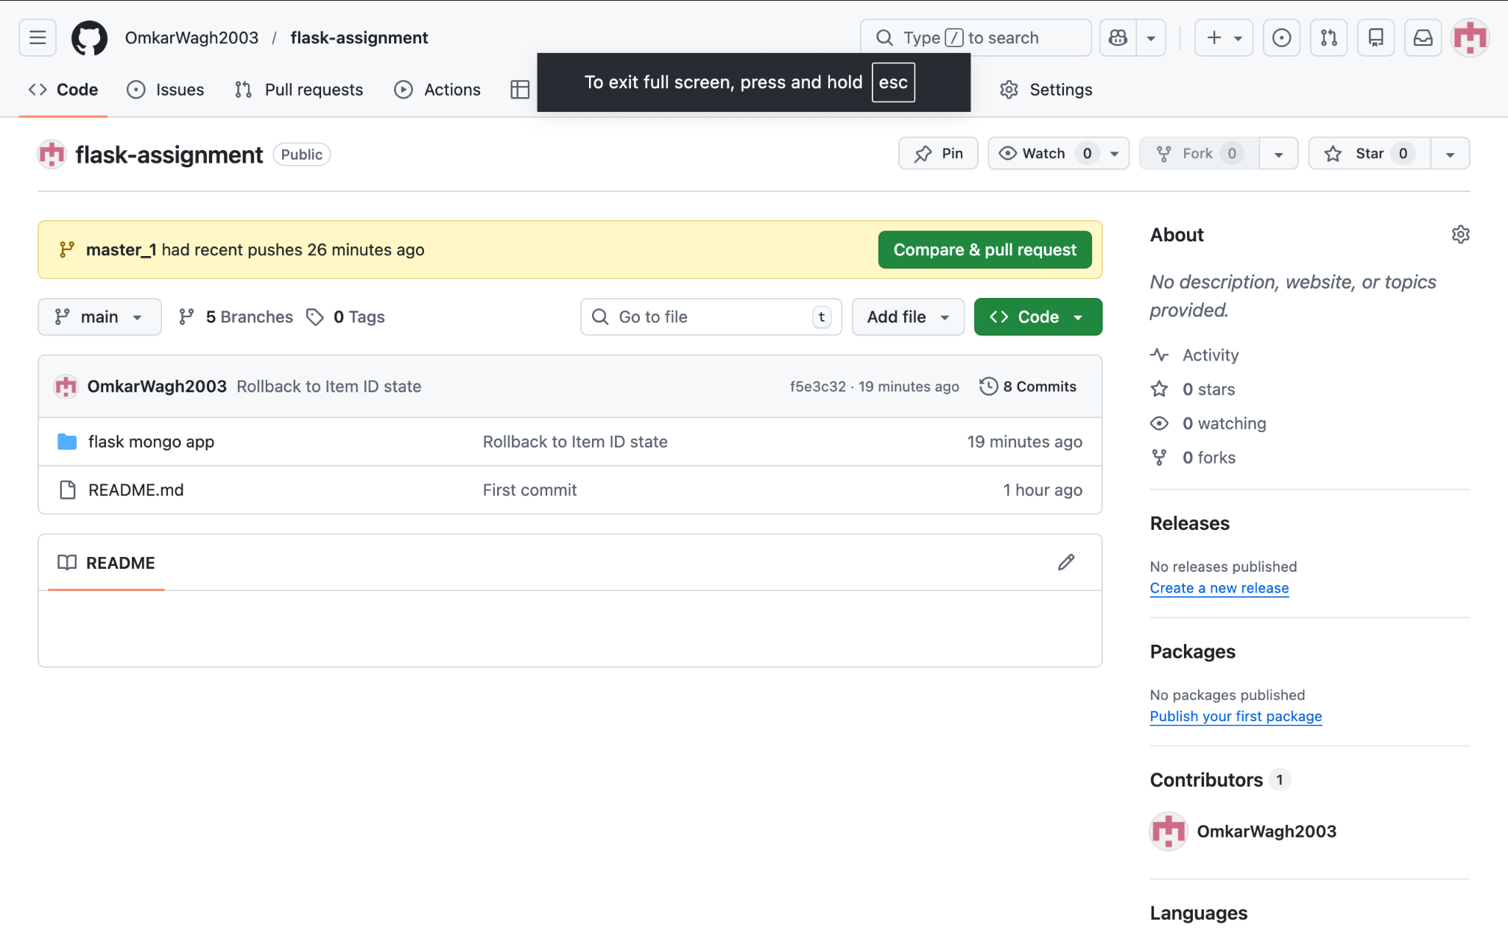

2. Branch Creation
Created multiple branches: OmkarWagh, OmkarWagh_new, master_1, master_2.
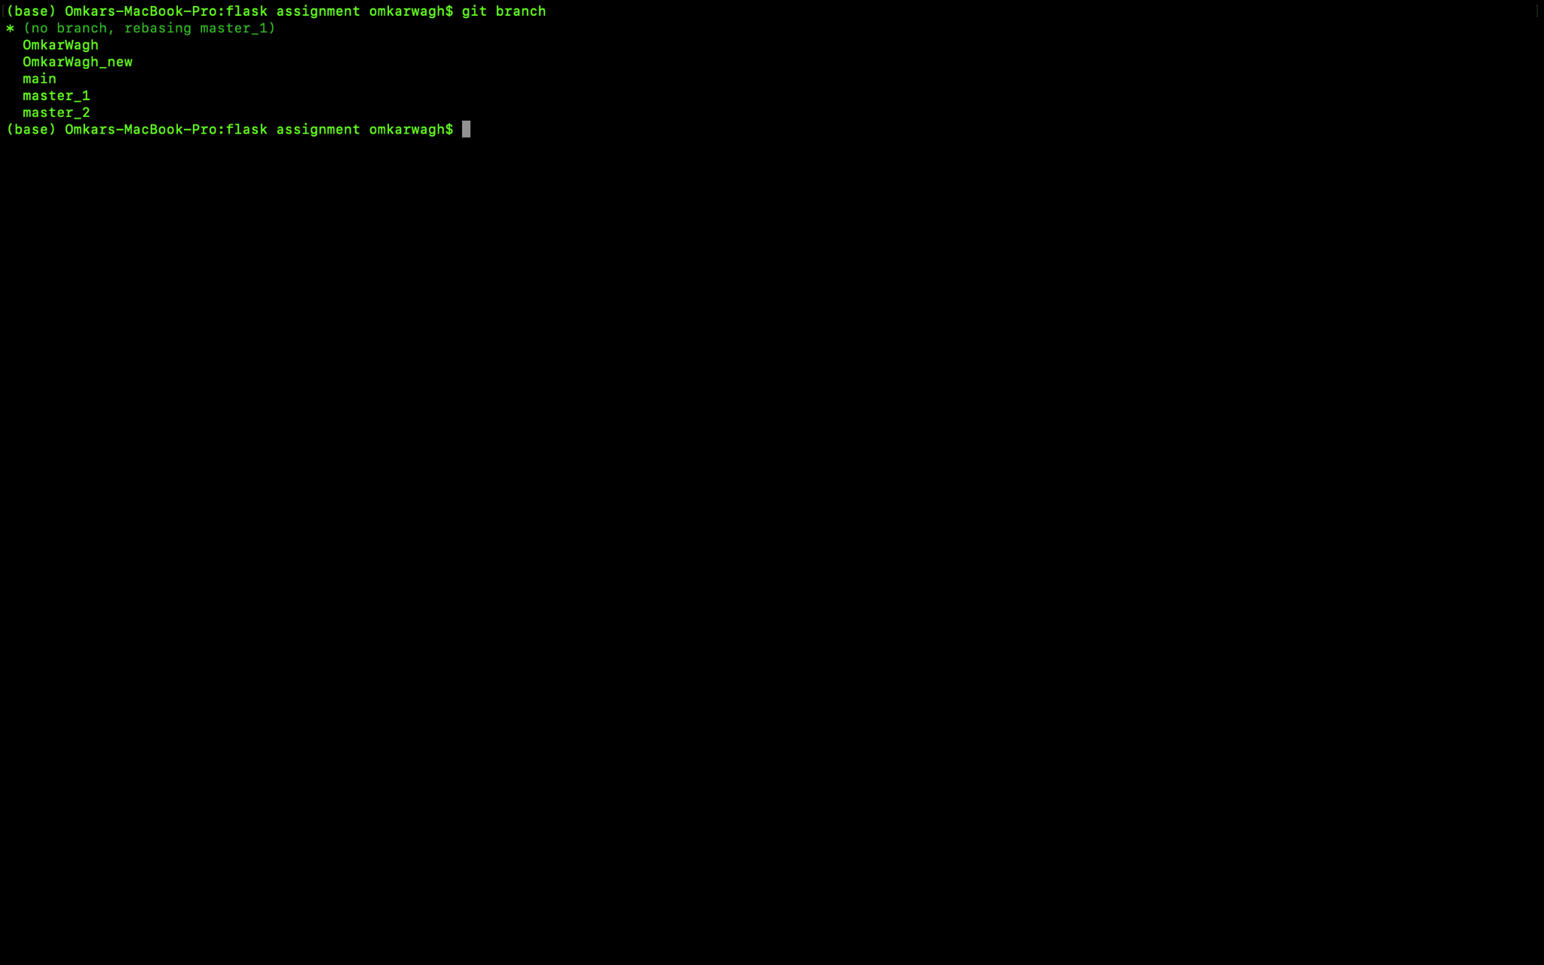

3. JSON Update
Updated JSON file for API in new branch.
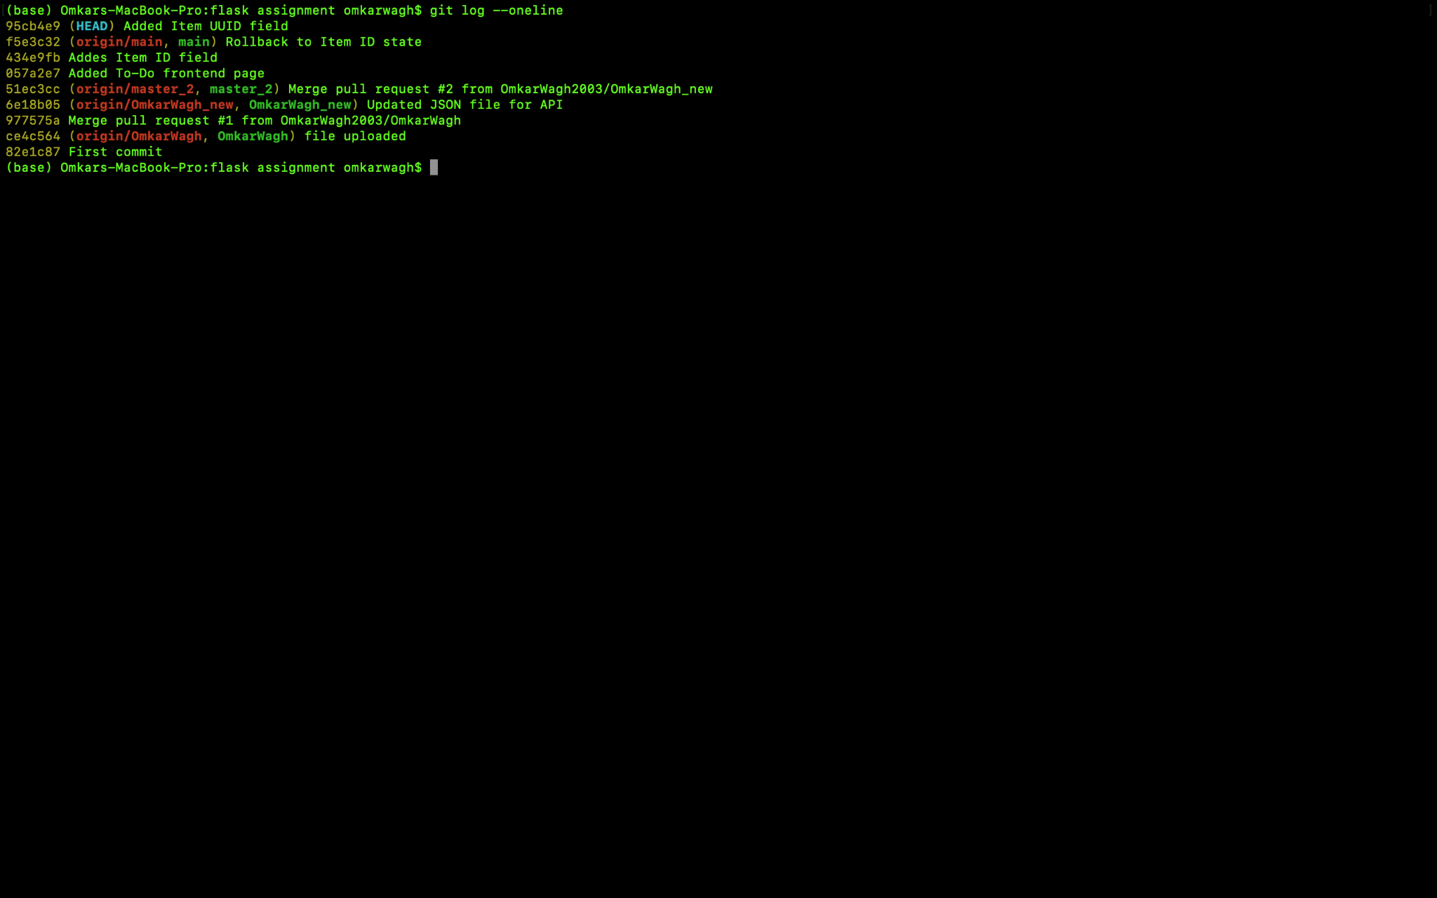

4. Backend API (master_2)
Created /submittodoitem route and MongoDB integration.
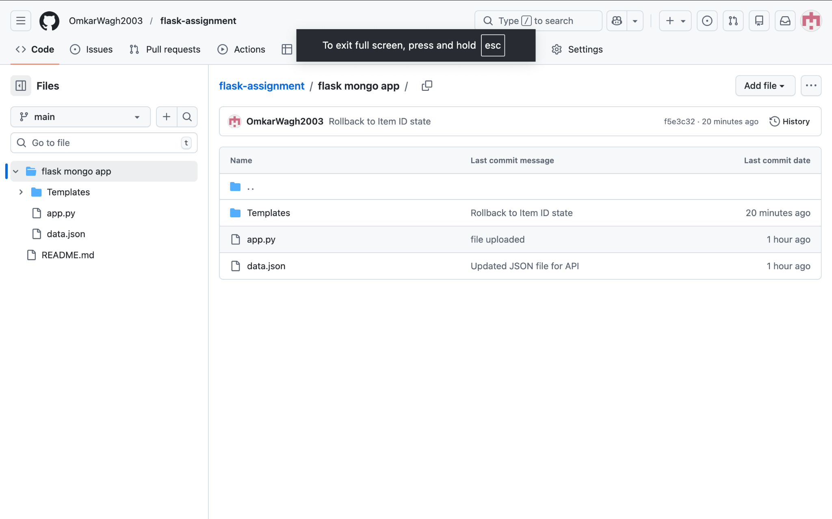

5. Frontend To-Do Page (master_1)
Created To-Do form with fields.
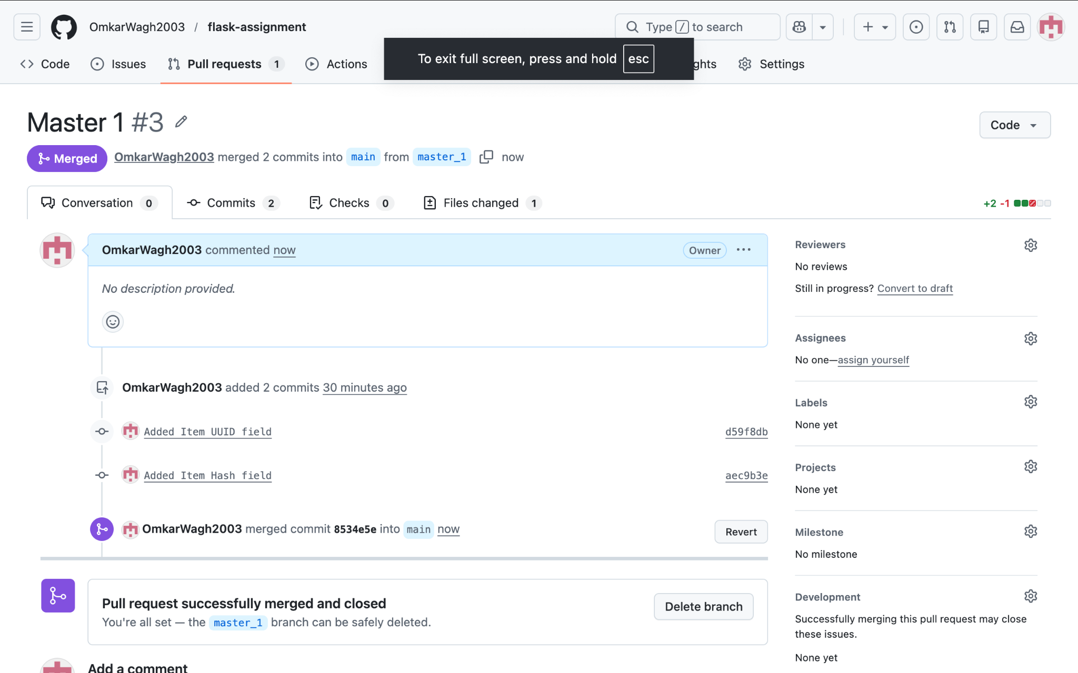

6. Pull Requests & Merges
Merged branches into main via pull requests.
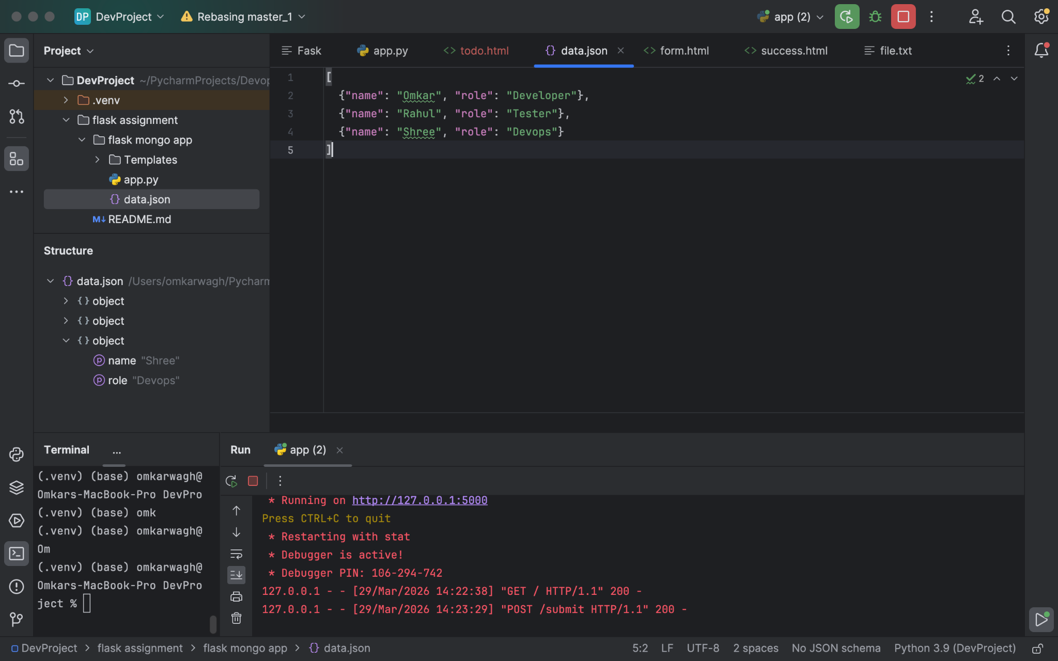

7. Commit History
Verified commit history using git log.
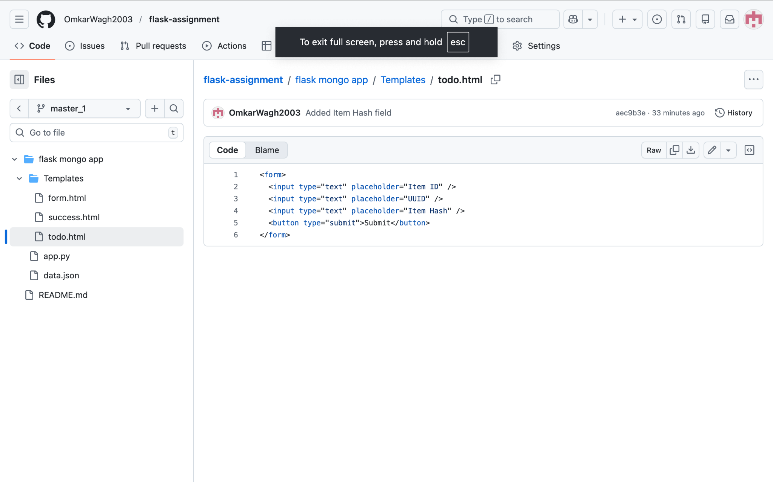

8. Detailed Commit Log
Detailed commit logs showing sequence of commits.
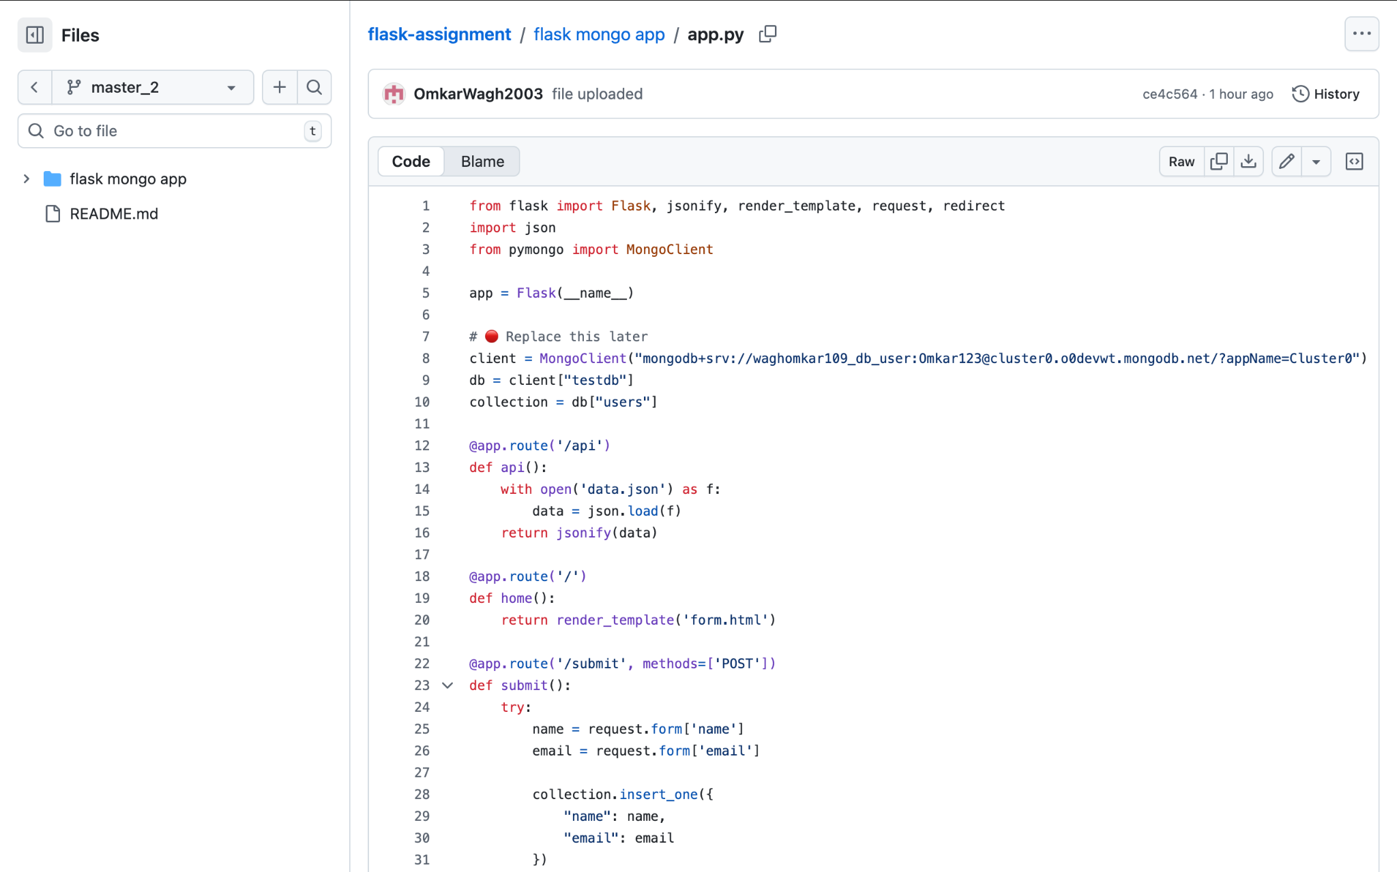

9. Final Repository State
Final project structure and files.
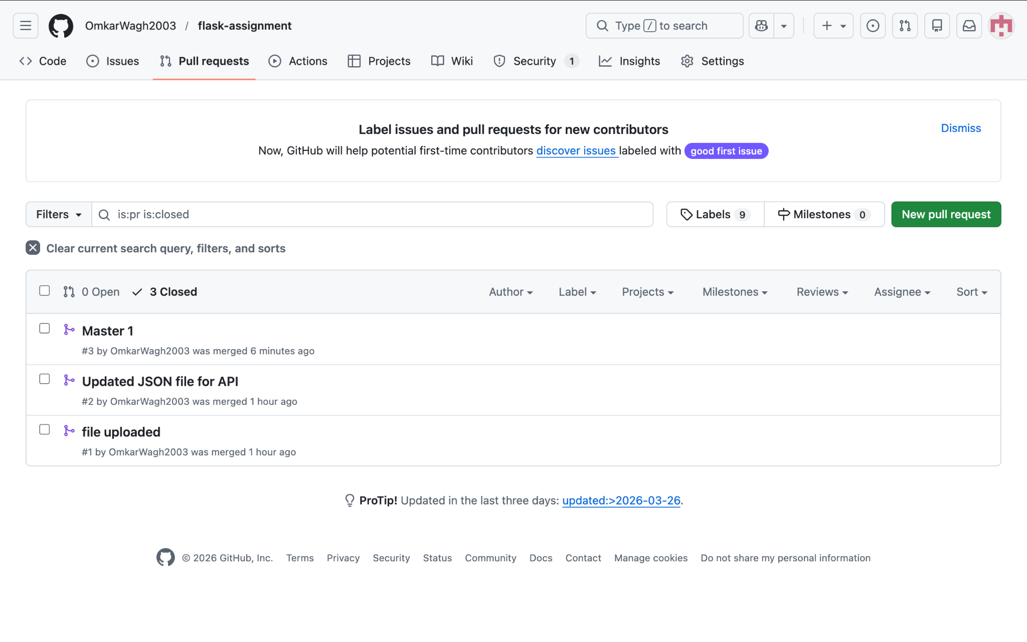

10. Final Verification
Final confirmation of merged pull requests.
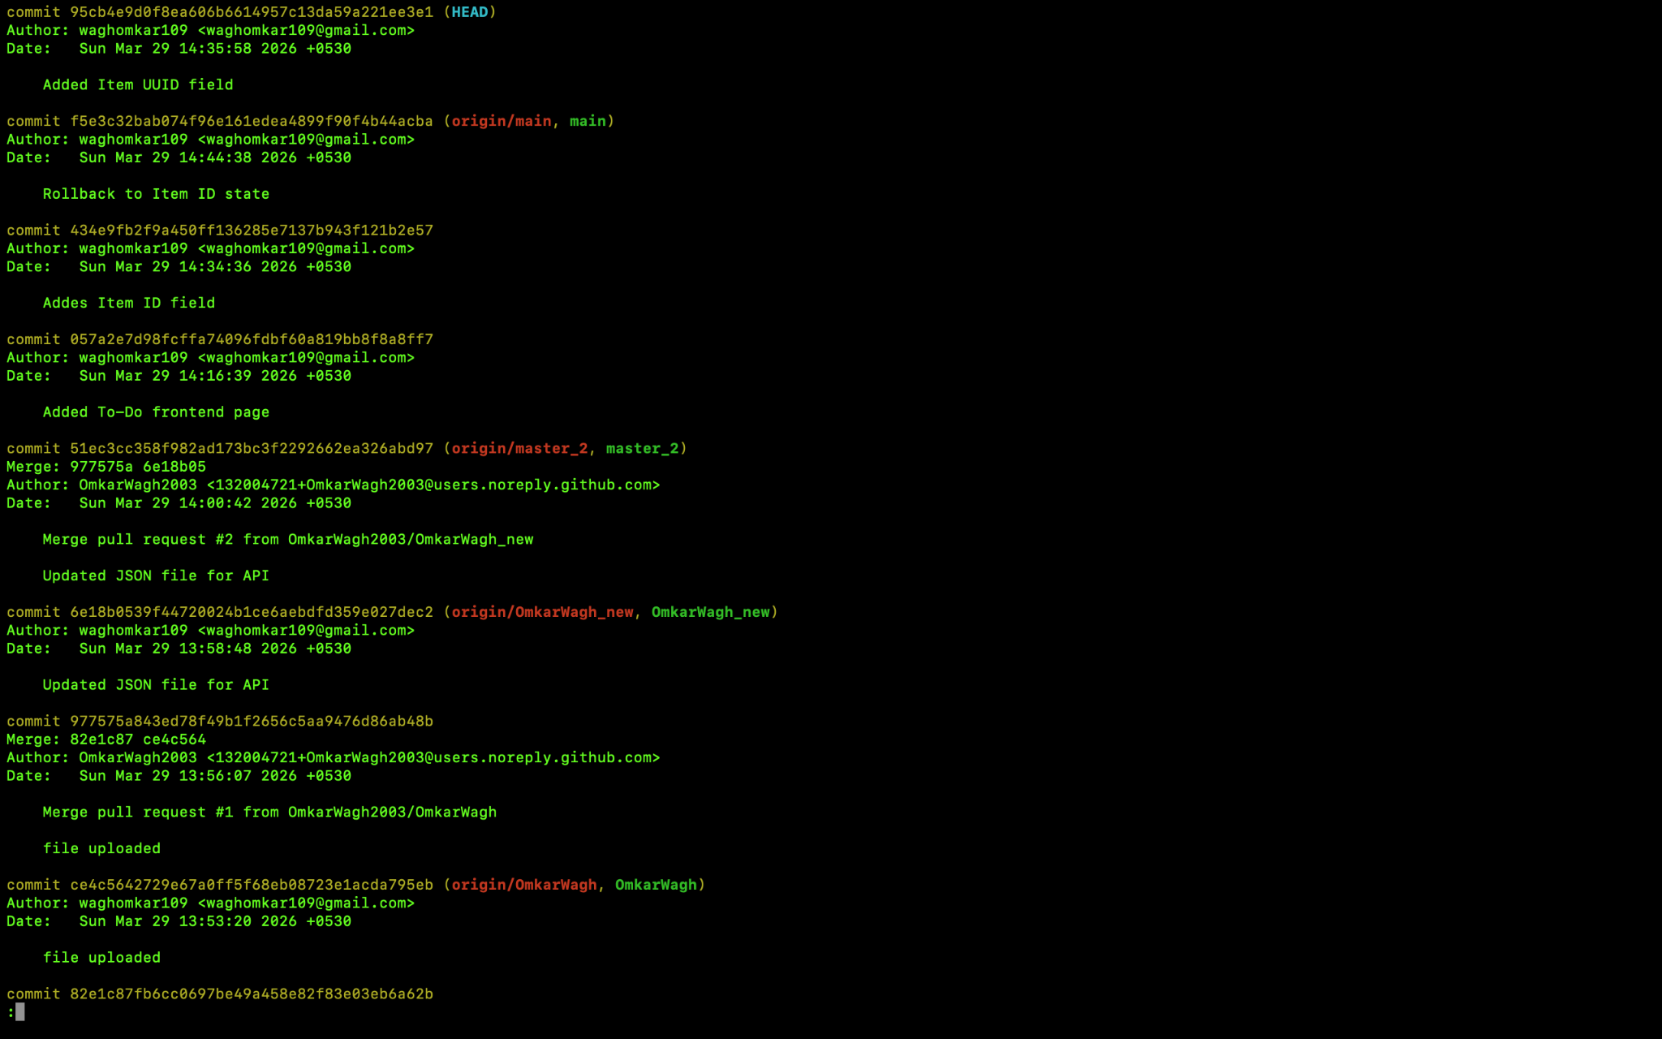

Git hub link

https://github.com/OmkarWagh2003/linux-basics-assignment

